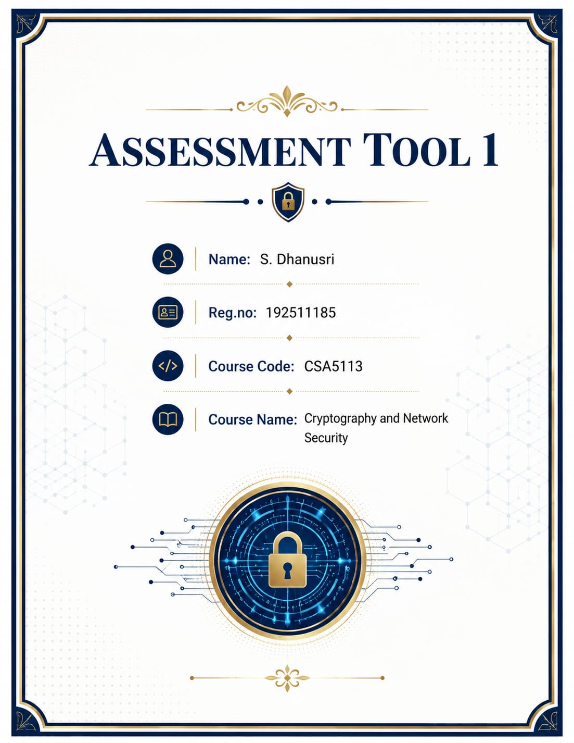
Q1. Event Communication Security (Caesar Cipher)

Given:
Plaintext: MEET AT NOON
Shift = +4
Step 1: Encryption
Plaintext | M | E | E | T | A | T | N | O | O | N
Shift +4 | Q | I | I | X | E | X | R | S | S | R

Ciphertext = "QIIX EX RSSR"
Step 2: Decryption
The receiver knows the shift is 4.
So each encrypted letter is shifted 4 positions backward.
Example:
Q → M
I → E
X → T
Thus,
QIIX EX RSSR → MEET AT NOON
Analysis
- Caesar Cipher uses one fixed shift for all letters.
- Sender and receiver must know the same key (Shift = 4).
- It is simple and fast but vulnerable to brute-force attacks because there are only 25 possible keys.
- Suitable only for basic educational purposes.
Conclusion
The encrypted message is:
QIIX EX RSSR
The original message is recovered by shifting every letter backward by four positions.

Q2. Intercepted Suspicious Message
Ciphertext:
GSRH RH Z HVXIVG
This is an Atbash Cipher.
Atbash replaces every alphabet with its opposite.
A↔Z
B↔Y
C↔X
D↔W
...
Decryption
Cipher | G | S | R | H | R | H | Z | H | V | X | I | V | G
Plain | T | H | I | S | I | S | A | S | E | C | R | E | T

Original Message = "THIS IS A SECRET"
Justification
- Repeated letters follow Atbash substitution.
- Letter frequencies remain unchanged because only substitutions occur.
- No letter positions are altered.
- Atbash is a monoalphabetic substitution cipher with a fixed reverse alphabet.
Analysis
Advantages
- Easy implementation
- No key exchange
Limitations
- Easily broken using frequency analysis.
- Not secure for modern communication.
Conclusion
The intercepted message is:
THIS IS A SECRET

Q3. Secure Messaging System (Vigenère Cipher)
Plaintext = HELLO
Keyword = KEY
Step 1
Repeat keyword
Plaintext: H E L L O
Keyword: K E Y K E
Step 2
Alphabet Values
H = 7
E = 4
L =11
L =11
O =14

K =10
E =4
Y =24
K =10
E =4
Step 3
Encryption
(7+10) =17 = R

(4+4) =8 = I

(11+24) =35
35 mod26 =9 = J

(11+10) =21 = V

(14+4) =18 = S
Ciphertext
RIJVS
Effect of Repeating Keyword
Since the keyword is shorter than the message, it repeats.
KEYKEYKEY...
Each repeated key letter changes the shift value.
Different letters in the plaintext receive different shifts, making the cipher much stronger than Caesar Cipher.
Analysis
Advantages
- Multiple shifting values
- Better resistance to frequency analysis
Limitations
- Weak if keyword is short or predictable.
- Vulnerable to Kasiski examination.
Conclusion
Plaintext:
HELLO
Keyword:
KEY
Ciphertext:
RIJVS

Q4. Suspicious Digital Asset Investigation (Steganography)
Detecting Hidden Data
Investigators can use:
1. LSB Analysis
Checks whether Least Significant Bits contain abnormal patterns indicating hidden information.
2. Statistical Analysis
Examines image histogram and pixel distribution for unusual modifications.
3. Steganalysis Software
Examples:
- StegExpose
- StegSolve
- OpenStego
These tools compare image characteristics and identify hidden payloads.
Improving Security
Technique 1
Encrypt the secret message using AES before embedding.
Even if extracted, attackers cannot read the contents.
Technique 2
Randomized Pixel Embedding
Instead of storing data sequentially, hide it in random pixel locations generated using a secret key.
This greatly increases resistance against steganalysis.
Analysis
Combining cryptography and steganography provides two layers of security:
- Encryption protects the message.
- Steganography hides its existence.
Conclusion
Investigators detect hidden data using LSB analysis, statistical analysis and steganalysis tools. Encrypting the message before embedding and using random pixel locations significantly improve confidentiality.

Q5. Legacy Encryption in Corporate Communication
Ciphertext:
WECRLTEERDSOEEFEAOCAIVDEN
(a) Original Message
This is the classic Rail Fence Cipher (3 rails).
After decryption:
WE ARE DISCOVERED FLEE AT ONCE
(b) Why is it Vulnerable?
- Only rearranges letters.
- Letter frequency remains unchanged.
- No secret substitution occurs.
- Can be broken using brute force.
- Modern computers can recover plaintext quickly.

(c) Practical Enhancement
Encrypt the message using AES-256 after performing the Rail Fence Cipher or replace it completely with AES.
Benefits
- Strong symmetric encryption
- Resistant to brute-force attacks
- Widely used in banking, military and secure communication
Analysis
Rail Fence provides only obfuscation, whereas AES provides true cryptographic security.
Conclusion
Original message:
WE ARE DISCOVERED FLEE AT ONCE
The Rail Fence Cipher is insecure for modern communication because it only changes character positions. Replacing it with AES or combining transposition with strong encryption greatly improves confidentiality.

